**Devops**

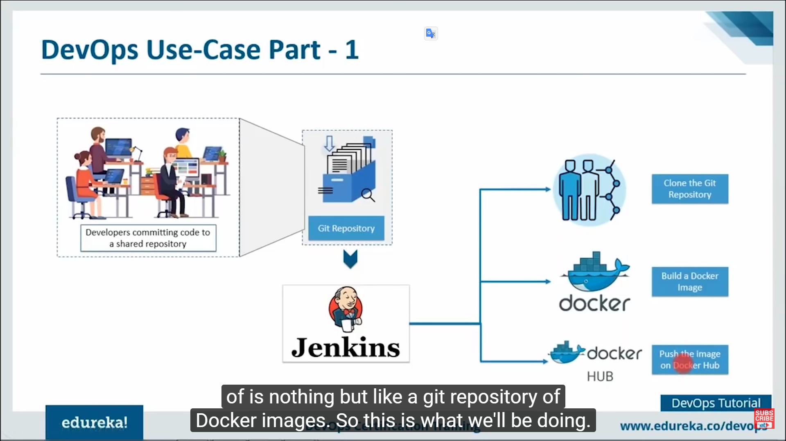

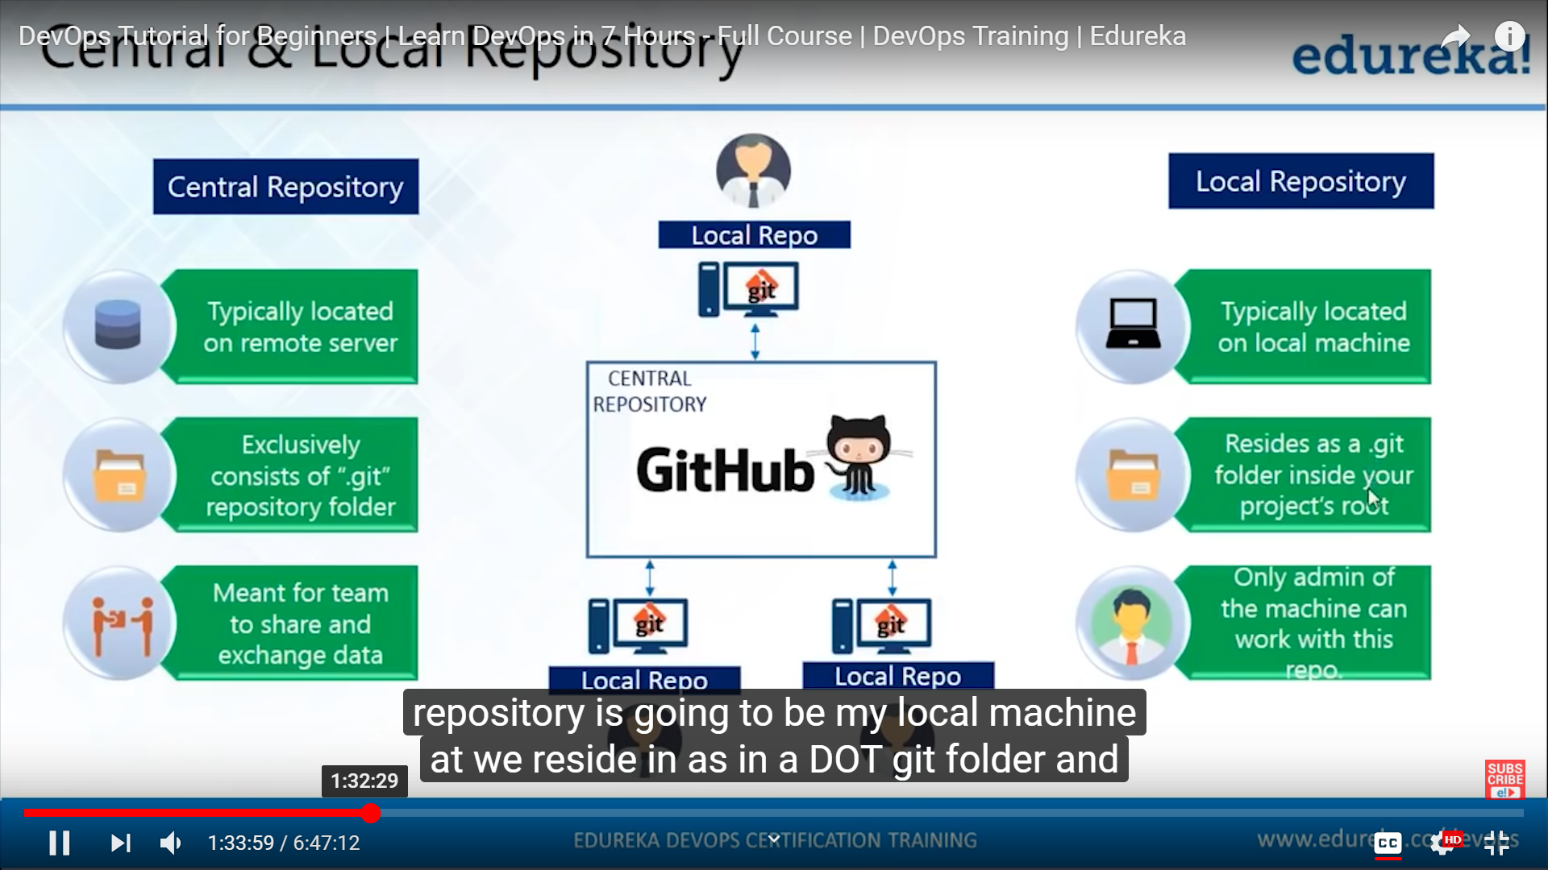

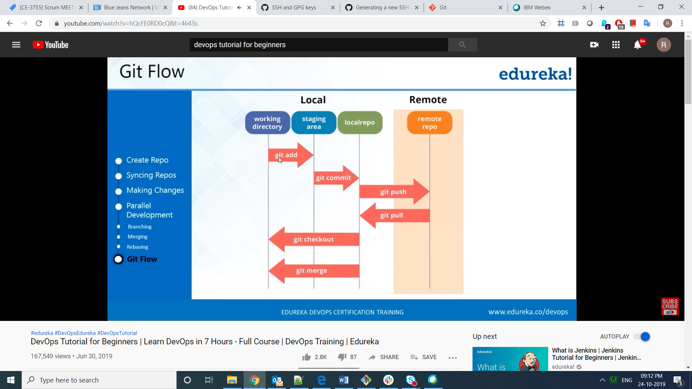

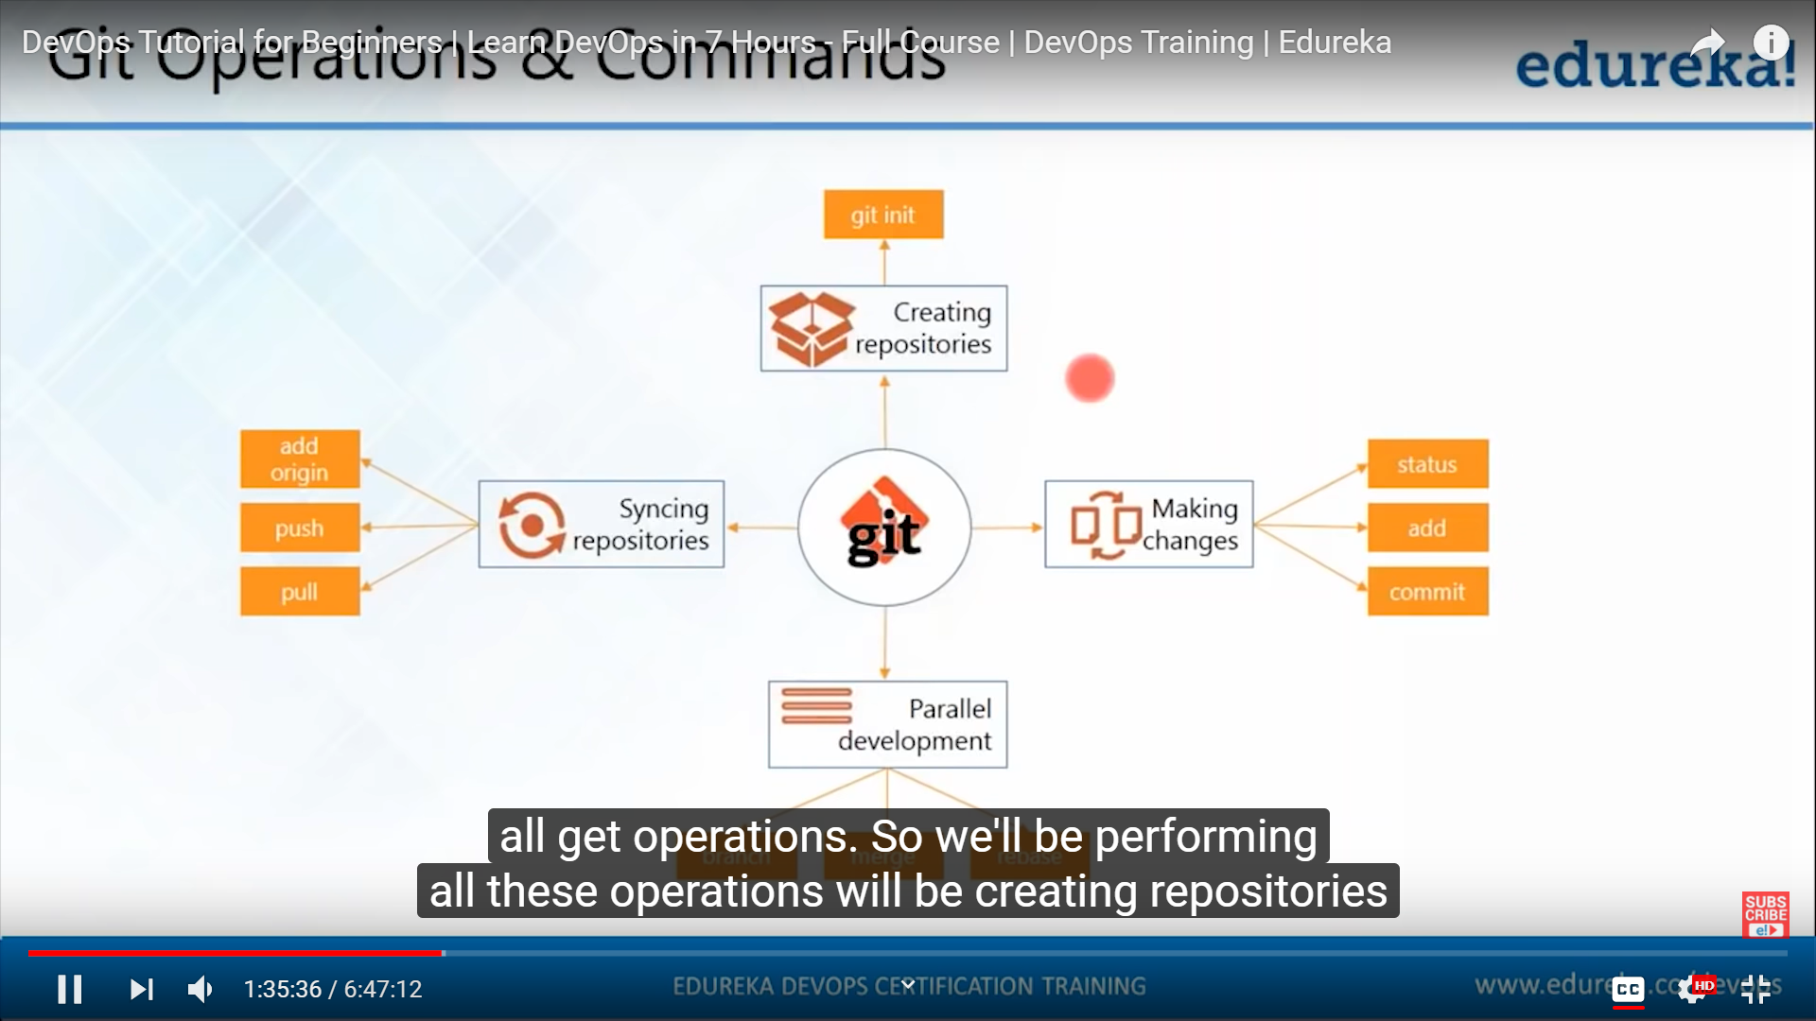

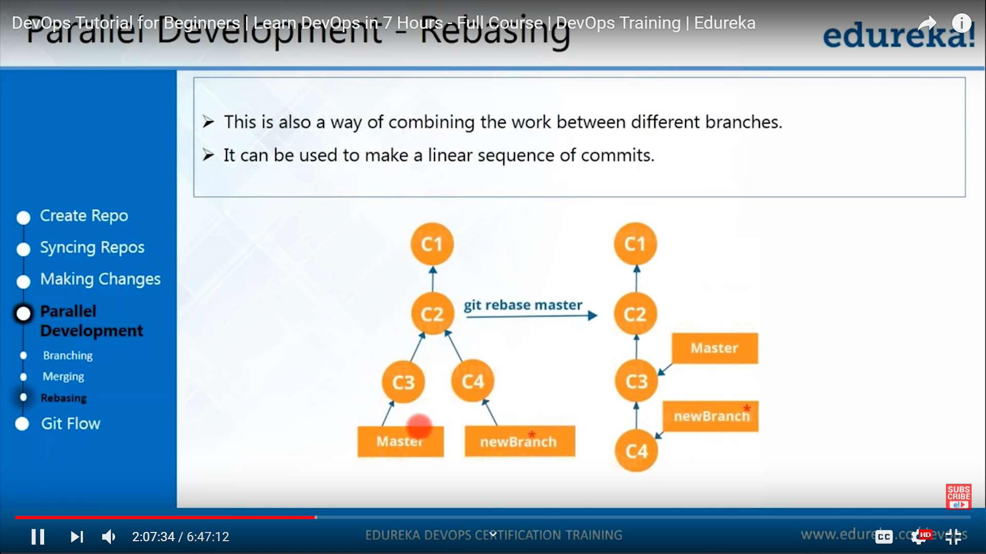

Deployment pipeline

Login --<https://github.com/>

Email-ruchita.chandel22@gmail.com

Pwd – github_ruchita22

git init

git remote add origin <https://github.com/Ruchita-22/demo.git>

git status

**Git command**

|  |  |
| --- | --- |
| git status | Check the status of index |
| git branch | Tell in which branch u r in |
| git add <filename> | Add particular file in index |
| git add .  git add -A | Add all the updated file to index |
| git checkout -b <branch_name> | Create a new branch |
| git branch <branch_name> | Create a new branch |
| git reset –hard origion/master |  |
| git reset | Revert the command of git add |
| Git commit -m “commit msg” | To commit the changes |
| git push origin <branch_name> | To push the changes in branch |
| git pull origin <branch_name> | To pull the changes of branch to local repository |
| Git merge firstbranch |  |
| Git commit -a -m “ ” | It will not work on untracked files. |
| cat <file_name> | To display a file on console |
| clear |  |
| git log |  |
| Git checkout <8digit hex code > <file-name> |  |

How to generate ssh key for security

ssh-keygen

y

cat path

copy ssh key

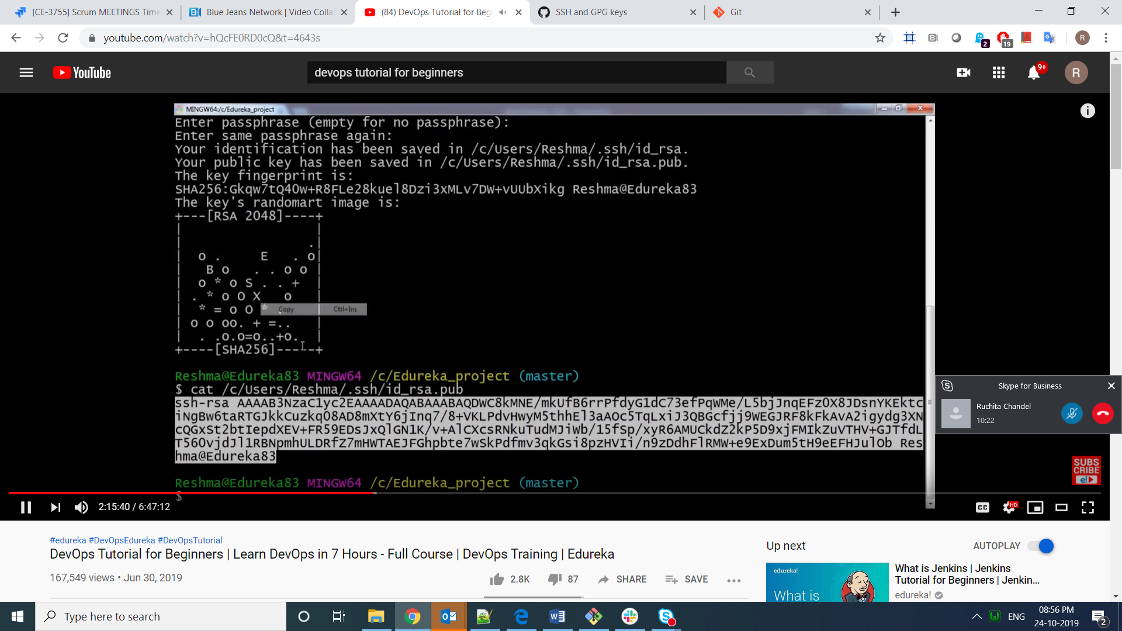

go to <https://github.com/settings/keys>

and paste your ssh key

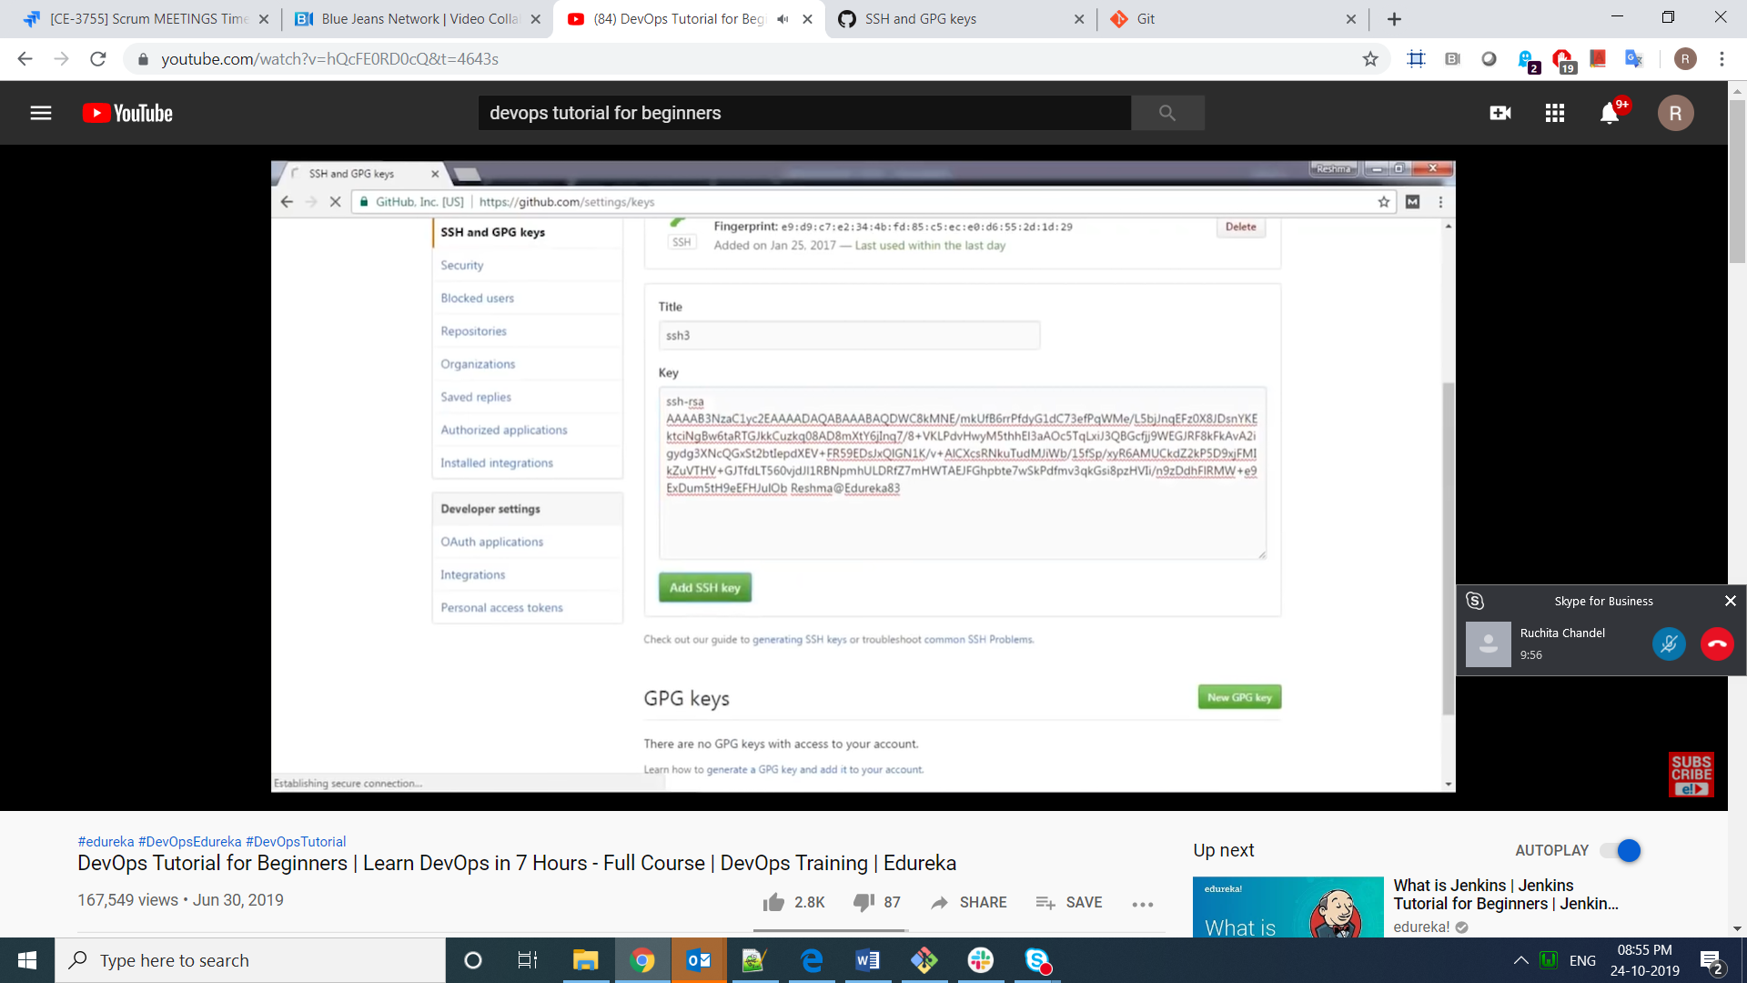

ssh -T [git@github.com](mailto:git@github.com)

if the key is green that means it is properly authentication

**Jenkins**

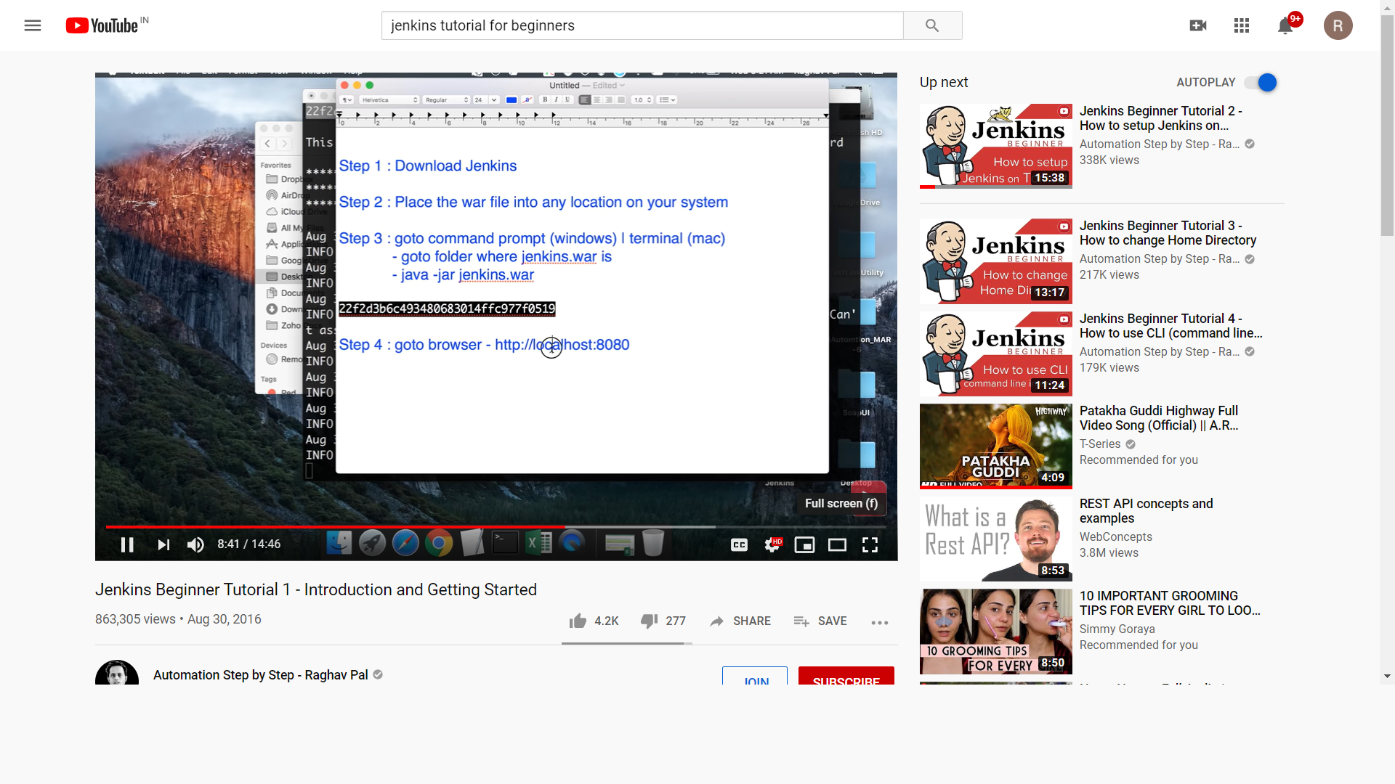

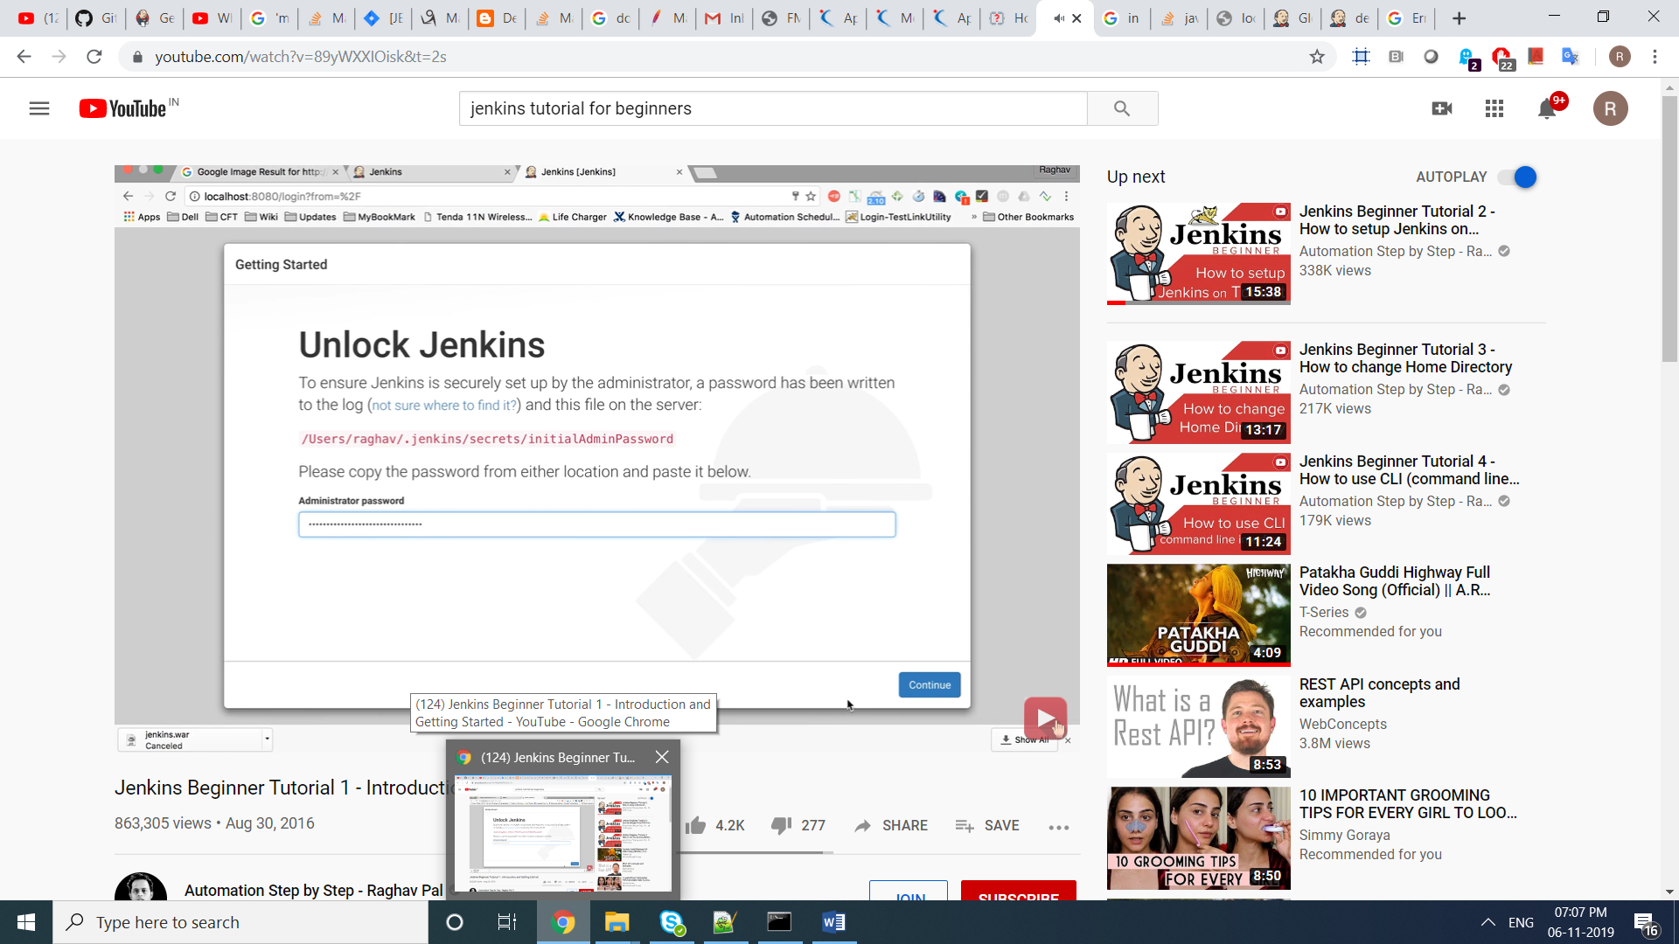

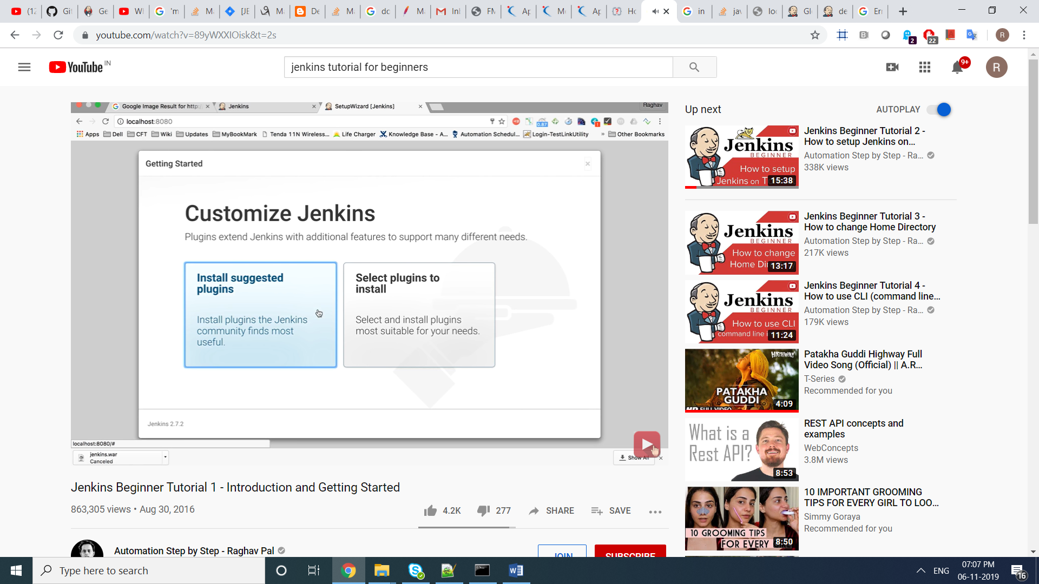

<http://localhost:8080/login?from=%2F>

location of pwd --C:\Program Files (x86)\Jenkins\secrets\initialAdminPassword

pwd --25cc36ba4df34f7d8c1b25e6e3c7dc88

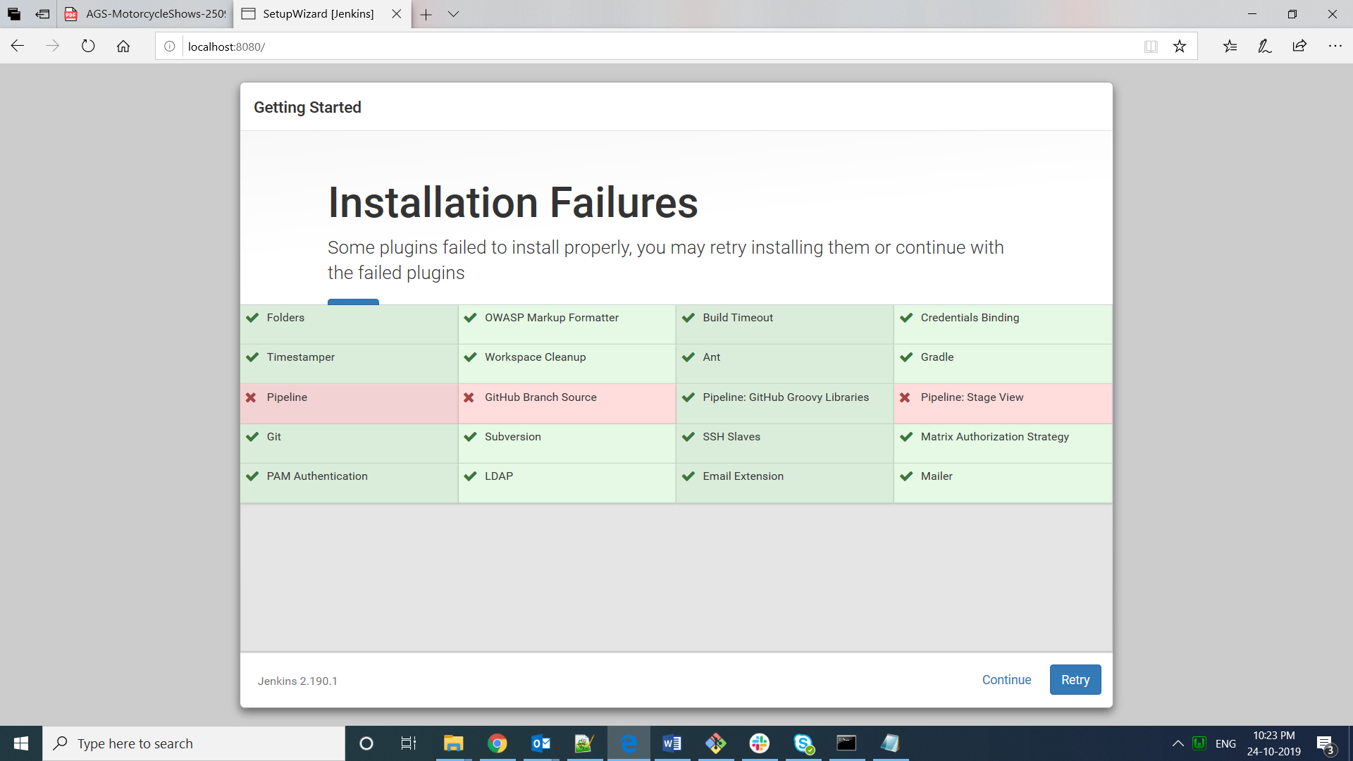

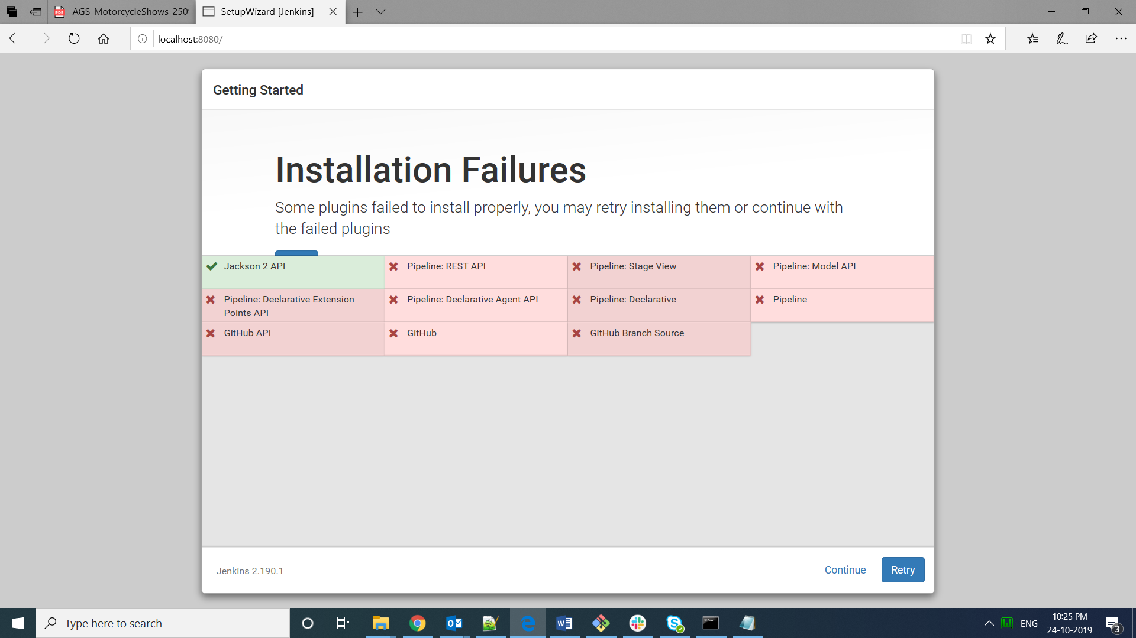

User – admin

Pwd—admin123

### Download and run Jenkins

1. [Download Jenkins](http://mirrors.jenkins.io/war-stable/latest/jenkins.war).
2. Open up a terminal in the download directory.
3. Run java -jar jenkins.war --httpPort=8080.
4. Browse to http://localhost:8080.
5. Follow the instructions to complete the installation.

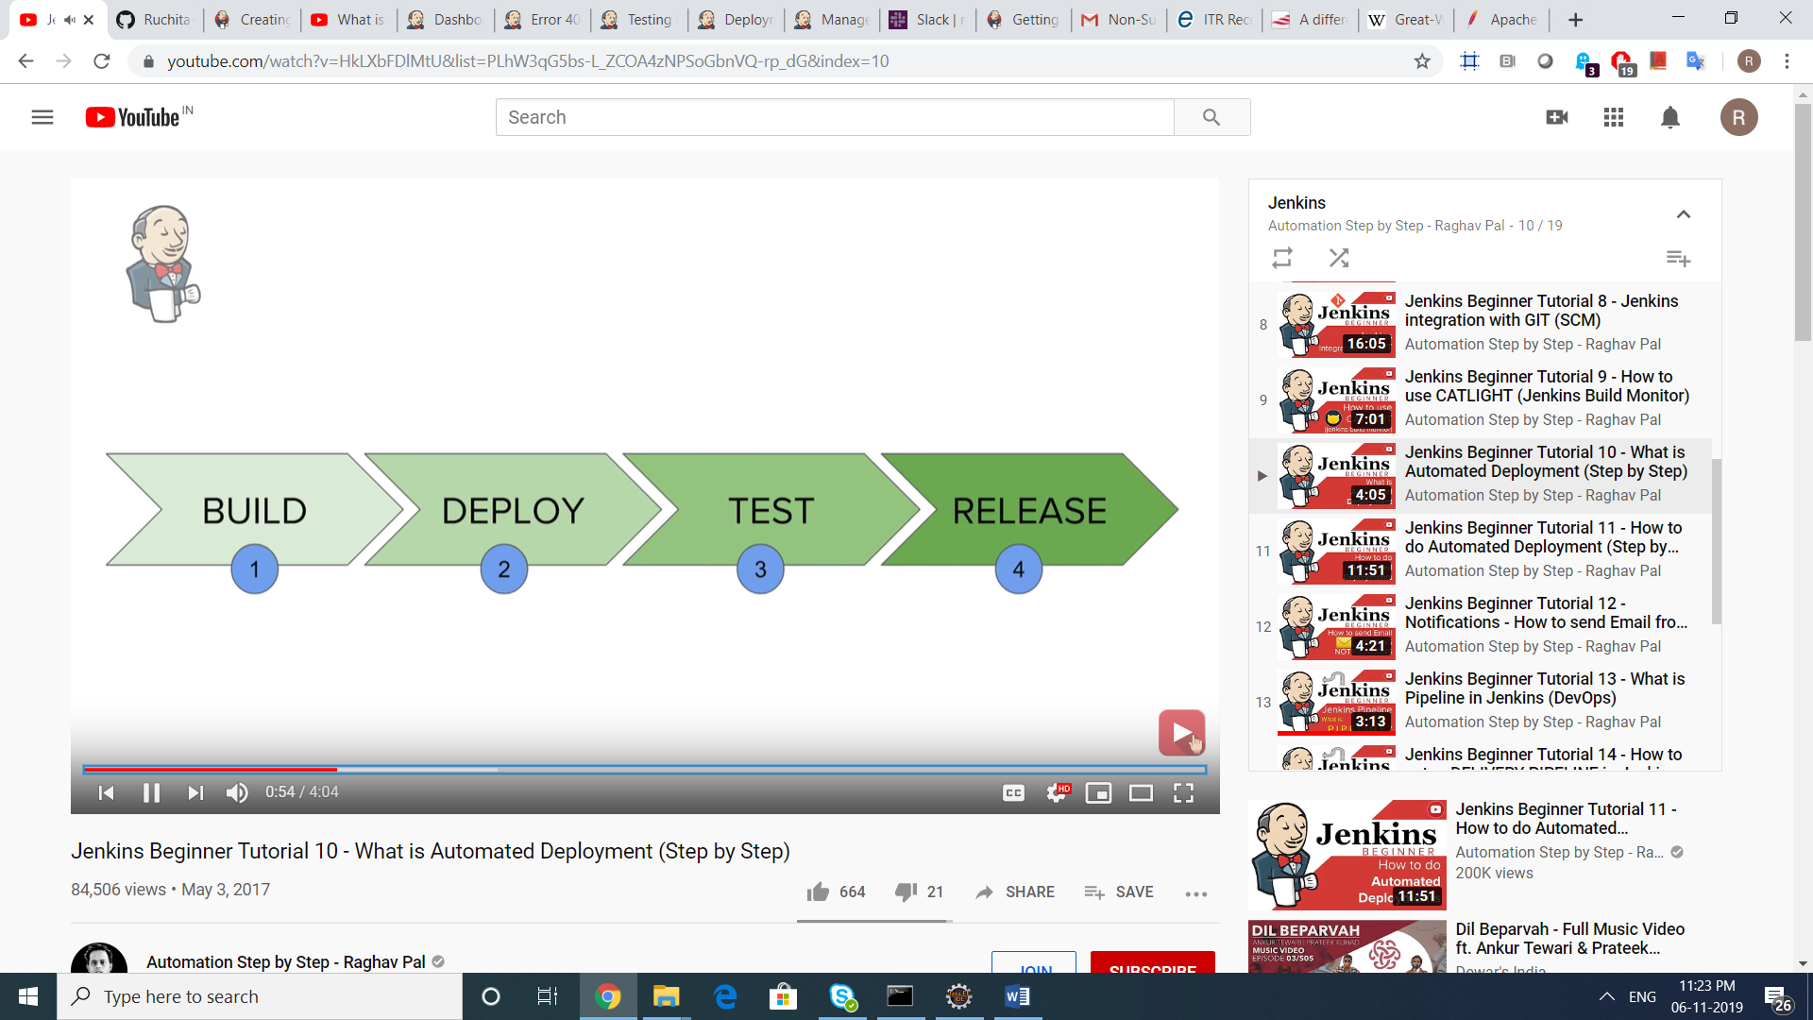

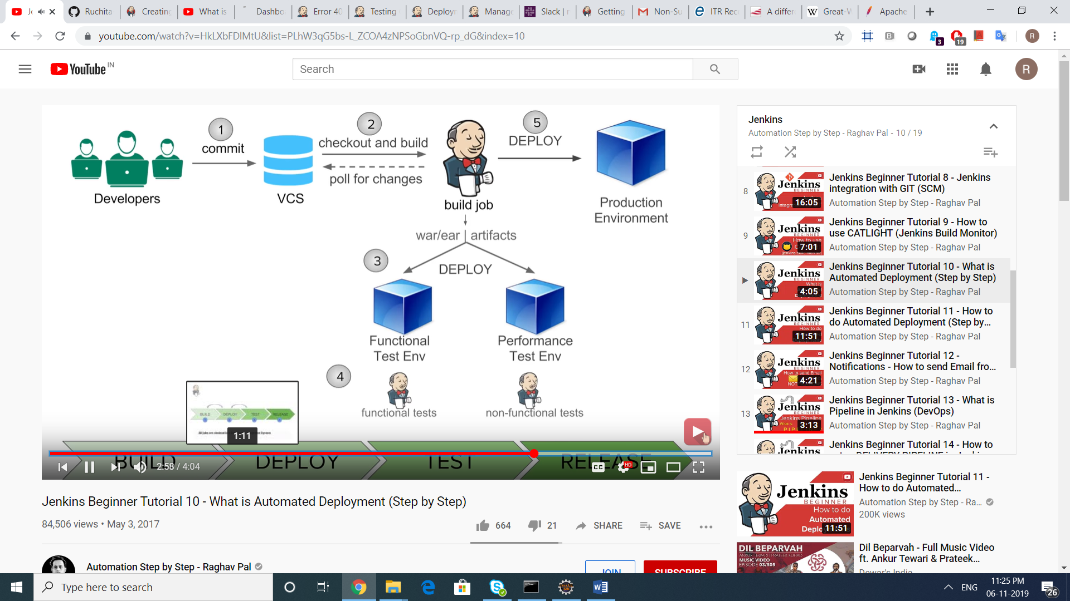

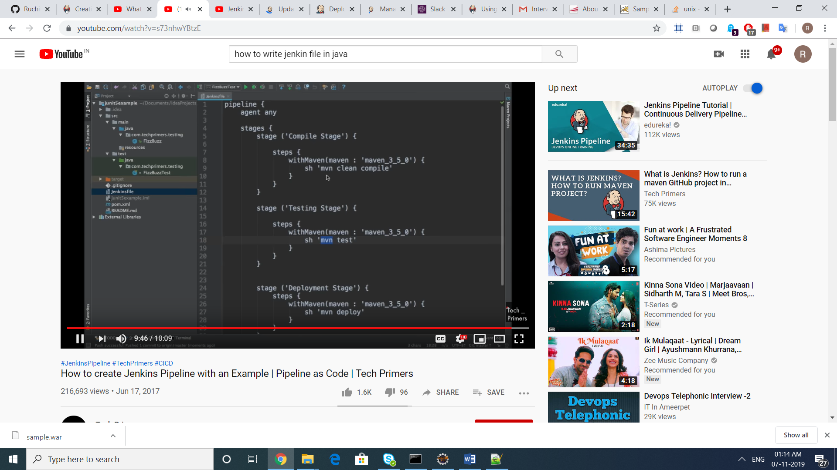

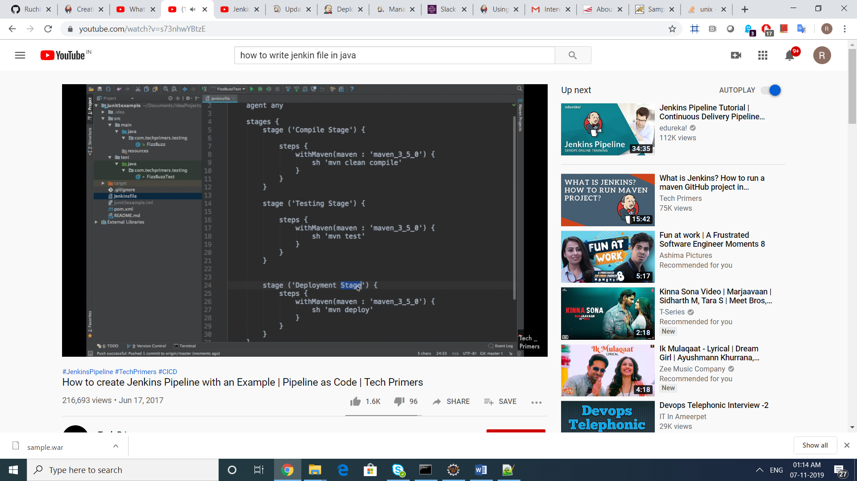

**Docker**

